Falcone’s Flyer September 17th, 2019

mfalcone@wcpss.net
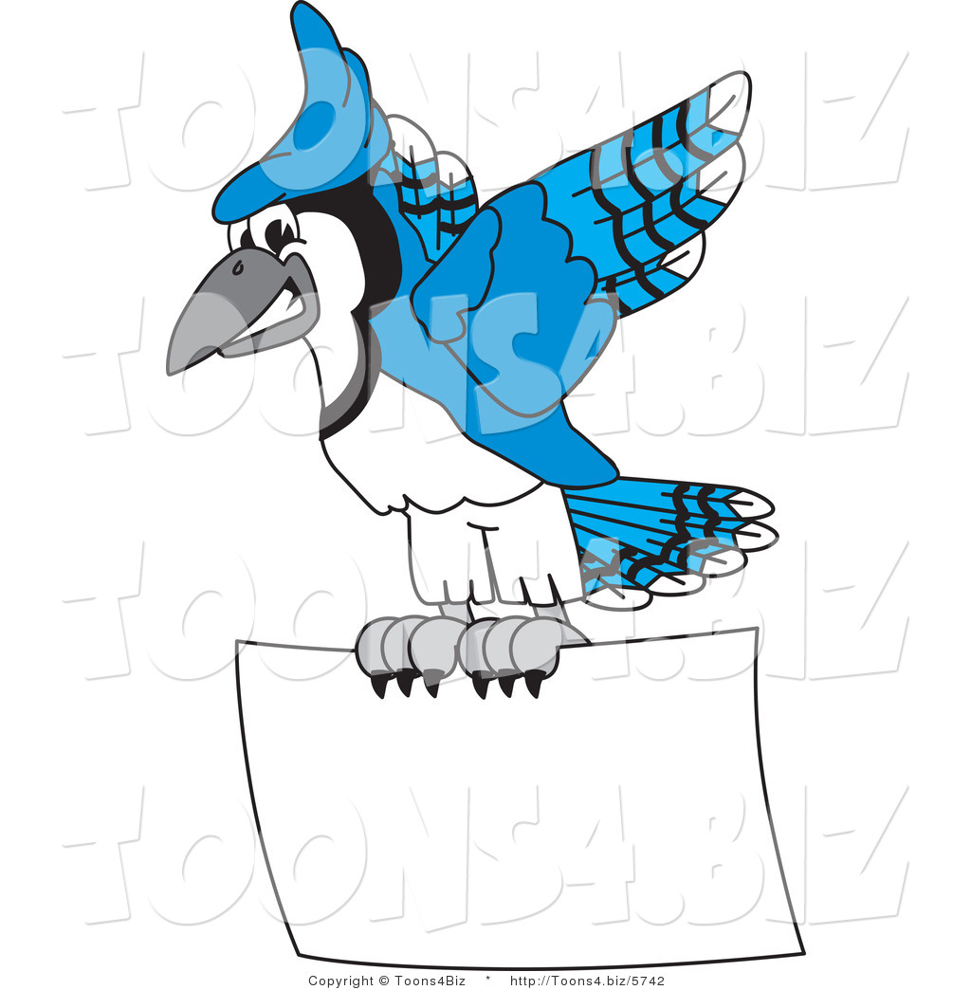

“Home of the Blue Jays”
UPCOMING IMPORTANT DATES

September

September 19th
National Dance Day Celebration
2:45 p.m.

September 30th
Teacher Workday
No School for Students

October

October 1st
Picture Day!!

October 4th
Quarter 1 Report Cards
Go Home

Academic News

In Math, we have begun learning about multiplicative comparison word problems. When we solve these problems, we are recognizing that we will either solve using multiplication or division. We have begun to discuss vocabulary such as “factor/factor pair,” “multiple,” “prime,” and “composite.” As a class, we are getting more comfortable with our multiplication facts! The students have begun making their own flash cards and will continue to practice independently as well as with peer support. Our next few units will involve factors & multiples as well as prime and composite numbers. We will also practice area and perimeter prior to the NC Check-In (Track 2’s Check-In is on October 23rd) and begin learning about multi-digit multiplication strategies. For support in using strategies we are learning in math for 4th grade, please visit my website at http://falcone7.weebly.com.
We have begun our science unit on fossils and Earth’s changing history. We have researched the topic of fossils and taken notes on the types of fossils. We have learned and discussed the following types: mold, cast, trace and true. The class studied and observed hermit shells and used model magic to make a replica of mold and cast fossils. In addition to discovering the importance of fossils, we will learn about the way that the Earth’s surface can change through slow or quick processes such as landslides, earthquakes and volcanoes.
In Reading, we have begun writing our own original poems showing what we are inspired by. These poems are fantastic!!! Some of the topics that have been chosen are animals, people, and special toys/objects. Students have now begun writing their paragraphs that describe their inspirations from their poems. The students will present them to one another at the end of this unit as we wrap up our first module of 4th grade! Our next module will focus on animal adaptations and students will be picking one animal to research using informational and scientific texts. This module will be essential as we will be reading multiple types of non-fiction texts as well as exploring the text features that come with non-fiction text (diagrams, table of contents, glossary, index, etc.)

WEEKLY QUOTE

“When you do the common things in life in an uncommon way, you will command the attention of the world.”

- George Washington Carver

Noteworthy

*** If you are interested in volunteering in the classroom, on a field trip, or at any
Sanford Creek event, please make sure that you have registered. Registration can take
some time to process, so please do this as soon as possible.

*** Please visit my website http://falcone7.weebly.com for resources in reading and
math that can support your child in using strategies that we learn this year in 4th grade.

*** Reviewing multiplication facts is very important for students in 4th grade. Our math
curriculum involves many units such as multiplication, division, fractions, and factors
& multiples. Some strategies students will start to think about using are flash cards,
songs, repeated addition, etc. Please continue to practice these strategies with your
child

*** If you have any questions, please don’t hesitate to e-mail me at
mfalcone@wcpss.net.

