Falcone’s Flyer January 14th, 2020

**mfalcone@wcpss.net**

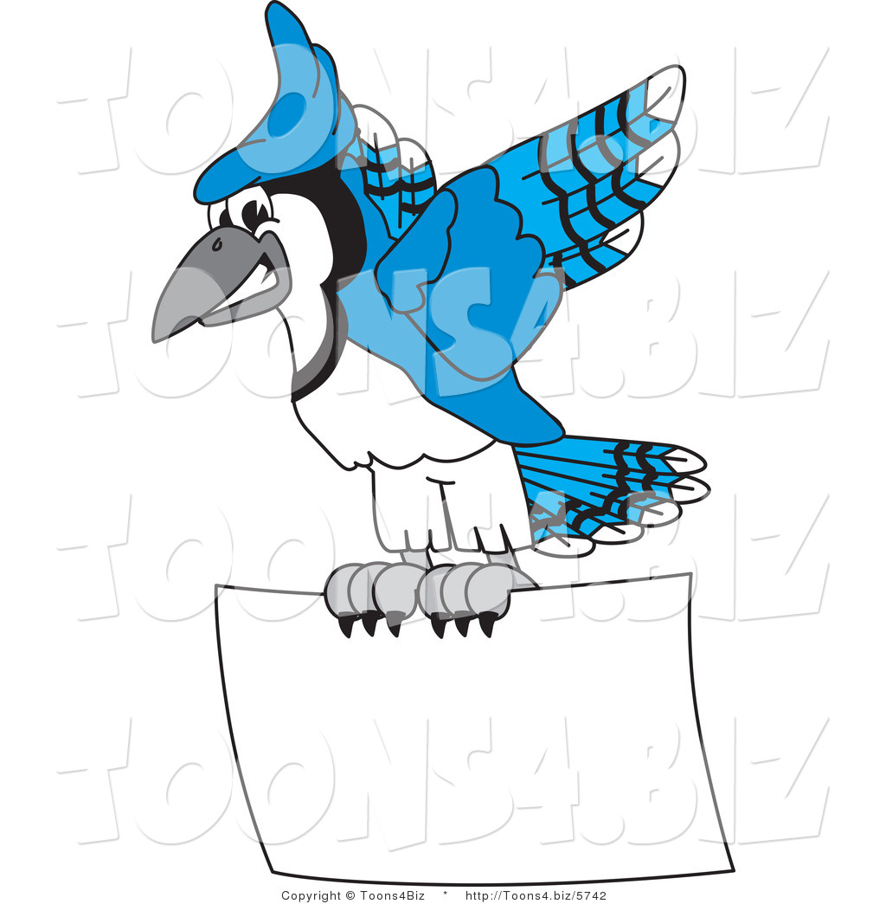

***“Home of the Blue Jays”***

**UPCOMING IMPORTANT DATES**

**January**

**January 20th**

Martin Luther King, Jr. Day

NO SCHOOL

**January 23rd**

Parent Academy Night

**January 27th**

PTA Meeting

6:00 p.m.

**February**

**February 3rd**

Quarter 3 Interims

Go Home

Academic News

In Math, we have begun learning about decimals and their relationships with fractions. We have learned the equivalence between tenths and hundredths as well as how to convert between tenths to hundredths and hundredths to tenths. We have used tools such as place value charts and hundredths grids to help us better our understanding of decimals. Once we finish this unit, we will move onto adding and subtracting fractions, which will also involve mixed numbers/improper fractions. We will also learn how to multiply whole numbers with fractions. For support in using strategies we are learning in math for 4th grade, please visit my website at <http://falcone7.weebly.com>.

We have begun our Science units, which will include Light and Magnetic Energy as well as Nutrition. We have started learning about the several types of energy that exist and then started to focus on light. We have learned that light travels in a straight line until it hits an object and light can **reflect, refract** and **absorb.** We will now start to learn about magnetic energy and have recently discussed that magnets have two poles, north and south. Opposite poles will attract and like poles will repel. We will experiment with iron filings, temporary magnets and electromagnets.

In Reading, we have started Module 3, which is about the American Revolution. We have learned that there were two main sides of this war: the British (Loyalists) and the colonists (Americans/Patriots.) We have started to dig into the informational texts about the events that led up to the war starting. For our performance task, students will consider different perspectives of this war and ultimately consider the question: ***“If you lived during colonial times, would you have supported the American Revolution? Why/why not?”*** We will be reading a historical fiction play titled, “Divided Loyalties,” which will help us see fictional characters from this historical event. We will analyze specific characters and use adjectives to describe them in specific and detailed ways. I can’t wait to see the creative ways that the students can show their thinking around this topic!! 😊

***WEEKLY QUOTE***

*“We do not need magic to change the world, we carry all the power we need inside ourselves already. We have the power to imagine better.”*

* ***J.K. Rowling***

Noteworthy

**\*\*\* If you are interested in volunteering in the classroom, on a field trip, or at any**

**Sanford Creek event, please make sure that you have registered. Registration can take**

**some time to process, so please do this as soon as possible.**

**\*\*\* Please visit my website** [**http://falcone7.weebly.com**](http://falcone7.weebly.com) **for resources in reading and**

**math that can support your child in using strategies that we learn this year in 4th grade.**

**\*\*\* Reviewing multiplication facts is very important for students in 4th grade. Our math**

**curriculum involves many units such as multiplication, division, fractions, and factors**

**& multiples. Students have created their own flash cards 2-12 and are continuing to**

**practice. More strategies used at home could be multiplication songs,**

**repeated addition practice, etc. Please continue to practice these strategies with your**

**child 😊**

**\*\*\* If you have any questions, please don’t hesitate to e-mail me at**

**mfalcone@wcpss.net.**